Mobile workshop Van
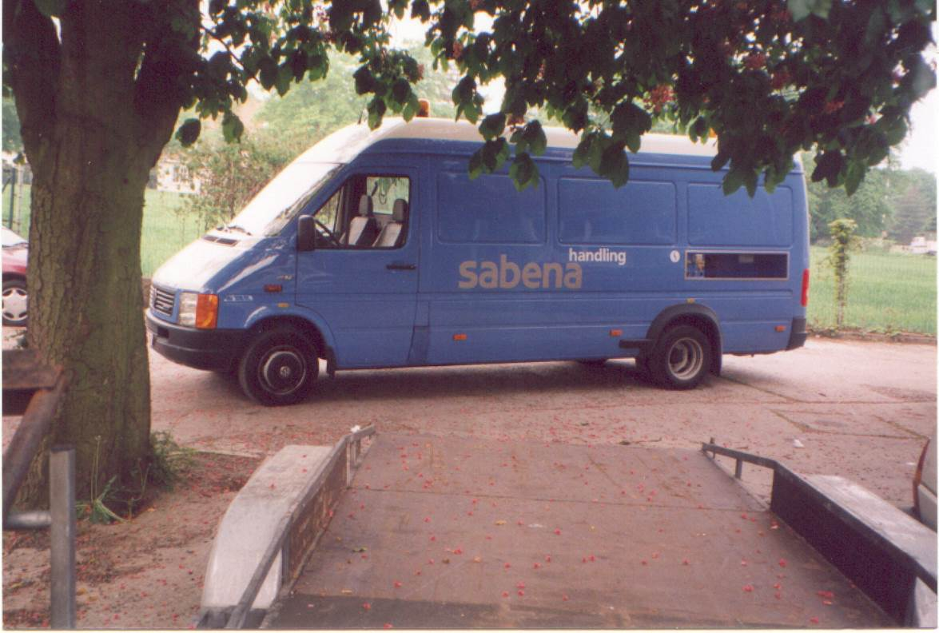

Specifications:
- Basic vehicle: VW Crafter wheelbase 4490 or Mercedes Sprinter with double alternator (210 Amps).
- 220 Volts compressor driven by 2500 Watt (5000 Watt maximum output) load- inverter combination, this makes external power supply possible.
- 10 bar 350 litre/minute compressor with 100 litre tank.
- Electronic engine speed adjustment and speed limiter.
- 3 air outlets, 1 from heavy duty hose reel with ½ inch air supply
- Interior light 3 x 16 Watt TL’s + 1 above the workbench and 1 in the driver cab
- Outside lights 2 x 55 Watt work lights
- 6 x 220 Volts plugs inside for machines and appliances
- Rockinger towing unit with additional bullet head.
- Tow-bar for quick car recovery
- Additional battery pack for up to 2400 Amps of start current at –18°C and 510 Ah.
- 12 and 24 Volt start electricity supply with 95 mm² cables for massive start capacity, stored in an integrated outside compartment.
- Equipped workshop with 33 drawers, from which 10 in removable case form and 15 with separation kit, 92 storage boxes, 5 tool panels and 1 workbench with vice
- Storage for 2 jerry cans and 1 oil collector reservoir
- 2 leatherette seat covers
- 2 orange warning lights on the roof, 2 fire extinguishers
- CE approved
- 2 year warranty on parts

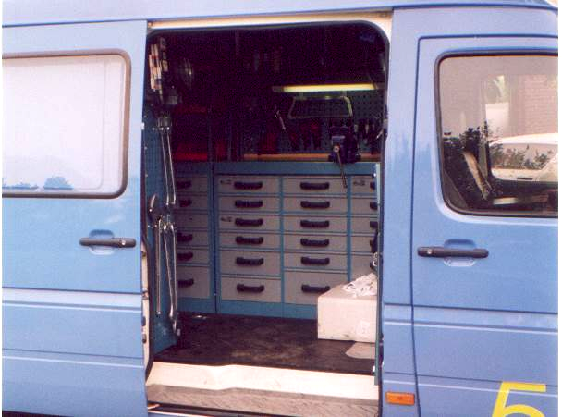

Options
- PTO driven under floor Compair rotary compressor of 600 litres/minute at 10.5 bars with under floor air tanks of 120 litres
- Under floor PTO driven generator of 10 kVA
- Roofrack
- Sink with (hot) water supply to clean hands and equipment
- Air-conditioning/heater unit on the roof
- Electro-hydraulic lift
